Task one

Add additional rows to the above table for the following dates: 2019-12-31, 2020-12-31, 2021-01-01, and 2027-01-01. (1P)
Answer
INSERT OR IGNORE INTO isotable
(date, dayofmonth, dayofyear, week, month,
weekday, year, yweek, isleapyear)
VALUES
('2019-12-31', 31, 365, 1, 12, 2, 2019, '2020-1', FALSE),
('2020-12-31', 31, 366, 53, 12, 4, 2020, '2020-53', TRUE),
('2021-01-01', 1, 1, 53, 1, 5, 2021, '2020-53', FALSE),
('2027-01-01', 1, 1, 53, 1, 5, 2027, '2026-53', FALSE);

Explain how the two SQL queries work that occur in the introductory comment of the piece of code mentioned as hint above. (1P)
Answer
The query groups rows by year, week, and dayofmonth. The COUNT(*) function counts the rows in each group, while HAVING COUNT(*) > 1 returns only groups containing duplicate combinations. If the result is empty, each combination is unique in the current dataset, suggesting that these attributes form a superkey. If the query returns any rows, the combination is not a superkey.

Identify all functional dependencies (FDs) of the form A → B, where A and B with A ̸= B are individual attributes (instead of sets). (2P)

Answer
SQL code:
SELECT A
FROM isotable
GROUP BY A
HAVING COUNT(DISTINCT B) > 1;
Output
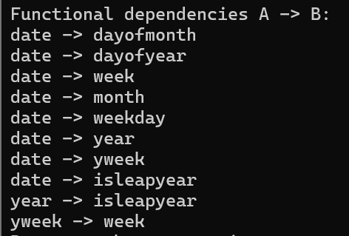

Find a key consisting of two attributes
Answer:
SELECT A, B
FROM isotable
GROUP BY A, B
HAVING COUNT(*) > 1;
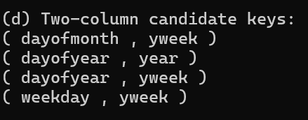

Find a functional dependency with a non-key, two-attribute left side
Answer:
SELECT A, B
FROM isotable
GROUP BY A, B
HAVING COUNT(DISTINCT C) > 1;
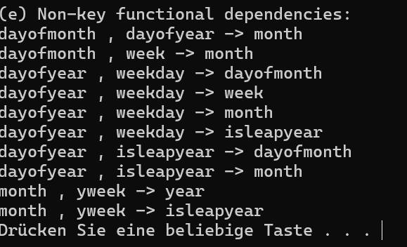

Task 3 – OLAP and SQL

(a) Compute the sum of quantity × unitprice
(i) SQL with an extended GROUP BY clause using CUBE
SELECT
Customer.CompanyName,
Product.ProductName,
Employee.LastName,
SUM(Sales.Quantity * Sales.UnitPrice) AS total
FROM Sales
JOIN Customer ON Sales.CustomerKey = Customer.CustomerKey
JOIN Product ON Sales.ProductKey = Product.ProductKey
JOIN Employee ON Sales.EmployeeKey = Employee.EmployeeKey
GROUP BY CUBE (
Customer.CompanyName,
Product.ProductName,
Employee.LastName
)
HAVING SUM(Sales.Quantity * Sales.UnitPrice) > 10000
ORDER BY total DESC;
Alternative: Using GROUPING SETS
SELECT
Customer.CompanyName,
Product.ProductName,
Employee.LastName,
SUM(Sales.Quantity * Sales.UnitPrice) AS total
FROM Sales
JOIN Customer ON Sales.CustomerKey = Customer.CustomerKey
JOIN Product ON Sales.ProductKey = Product.ProductKey
JOIN Employee ON Sales.EmployeeKey = Employee.EmployeeKey
GROUP BY GROUPING SETS (
(Customer.CompanyName, Product.ProductName, Employee.LastName),
(Customer.CompanyName, Product.ProductName),
(Customer.CompanyName, Employee.LastName),
(Product.ProductName, Employee.LastName),
(Customer.CompanyName),
(Product.ProductName),
(Employee.LastName),
()
)
HAVING SUM(Sales.Quantity * Sales.UnitPrice) > 10000
ORDER BY total DESC;

(ii) Traditional GROUP BY using UNION ALL
WITH base AS (
SELECT
Customer.CompanyName AS companyname,
Product.ProductName AS productname,
Employee.LastName AS lastname,
Sales.Quantity * Sales.UnitPrice AS amount
FROM Sales
JOIN Customer ON Sales.CustomerKey = Customer.CustomerKey
JOIN Product ON Sales.ProductKey = Product.ProductKey
JOIN Employee ON Sales.EmployeeKey = Employee.EmployeeKey
)
SELECT *
FROM (
SELECT companyname, productname, lastname,
SUM(amount) AS total
FROM base
GROUP BY companyname, productname, lastname
UNION ALL
SELECT companyname, productname, NULL,
SUM(amount)
FROM base
GROUP BY companyname, productname
UNION ALL
SELECT companyname, NULL, lastname,
SUM(amount)
FROM base
GROUP BY companyname, lastname
UNION ALL
SELECT NULL, productname, lastname,
SUM(amount)
FROM base
GROUP BY productname, lastname
UNION ALL
SELECT companyname, NULL, NULL,
SUM(amount)
FROM base
GROUP BY companyname
UNION ALL
SELECT NULL, productname, NULL,
SUM(amount)
FROM base
GROUP BY productname
UNION ALL
SELECT NULL, NULL, lastname,
SUM(amount)
FROM base
GROUP BY lastname
UNION ALL
SELECT NULL, NULL, NULL,
SUM(amount)
FROM base
) AS all_groups
WHERE total > 10000
ORDER BY total DESC;
Explanation:
The traditional GROUP BY approach uses eight separate queries to calculate the aggregates for all possible subsets of the three attributes. UNION ALL combines their results into one table. NULL represents attributes that are not included in a particular grouping. Finally, the WHERE condition filters totals greater than 10,000, and ORDER BY sorts the results in descending order.

(b) Compute the sum of quantity along the geographical customer hierarchy
SQL with an extended GROUP BY clause using ROLLUP
SELECT
Customer.CompanyName,
City.CityName,
State.StateName,
Country.CountryName,
SUM(Sales.Quantity) AS total
FROM Sales
JOIN Customer
ON Sales.CustomerKey = Customer.CustomerKey
JOIN City
ON Customer.CityKey = City.CityKey
JOIN State
ON City.StateKey = State.StateKey
JOIN Country
ON State.CountryKey = Country.CountryKey
GROUP BY ROLLUP (
Customer.CompanyName,
City.CityName,
State.StateName,
Country.CountryName
)
HAVING SUM(Sales.Quantity) > 100
ORDER BY total DESC;
Explanation:
The ROLLUP clause calculates the sum of quantity at different levels of the geographical customer hierarchy. It starts with the most detailed level (CompanyName, CityName, StateName, and CountryName) and progressively removes the last attribute to calculate higher-level aggregates.
The five grouping levels are:
- CompanyName, CityName, StateName, CountryName
- CompanyName, CityName, StateName
- CompanyName, CityName
- CompanyName
- All (Grand Total)
The HAVING condition includes only groups where the sum of quantity is greater than 100. Finally, ORDER BY total DESC sorts the results in descending order of total.

